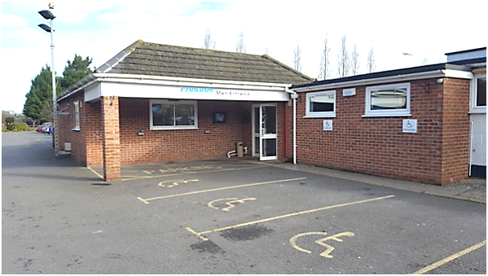
Joining Instructions
for Cobham Sports & Social Club
Merley Park Road, Ashington
Wimborne BH21 3DA
DT4 0QF
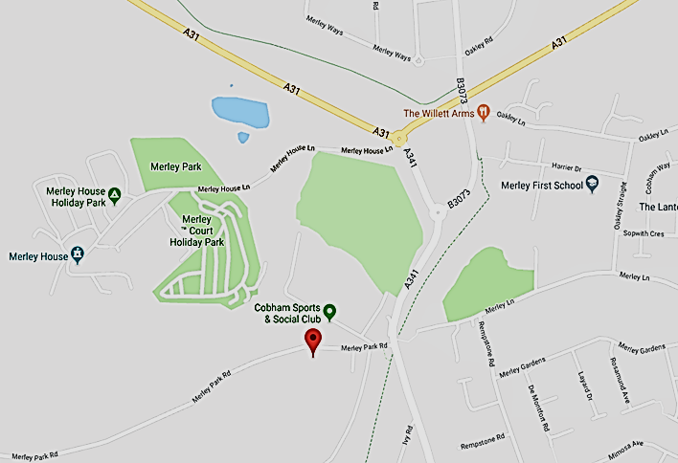
In light of the COVID concerns please ensure you check the Dorset Road safe website Dorset Road Safety | Dorset Road Safety for updates in relation to classroom cancellations

The DAS classroom is situated inside the Cobham Sports & Social Club

Directions:
From the Canford Bottom roundabout proceed along the A31 to the Merley Roundabout. Take the 1st exit A341 towards Poole. Turn right onto Merley Park Road, directly ahead you will see a large sign for the venue.

FREE car park on site. Disabled parking spaces available.

Classroom location:
Please report to the lounge bar area where you will be met by an instructor for registration. Your temperature will be taken on arrival, anyone showing a higher than normal temperature will be refused entry to the premises.

Refreshments:
Free tea/coffee is available at the break during your course.

No Smoking
Please note that the building is a NO SMOKING site: you may smoke outside the main building.

Please see our website for further details www.dorsetroadsafe.org.uk

PLAN YOUR JOURNEY

Please ensure you check your planned route for any roadworks that may delay your journey.

Details of planned roadworks for the Dorset area can be found on:

www.dorsetforyou.gov.uk

www.bournemouth.gov.uk

www.poole.gov.uk/transport-and-streets/roads-highways-and-pavements/road-works

Please be aware

As per our terms and conditions latecomers will NOT be admitted to the course which will result in the course offer being withdrawn.

THE ORIGINAL COURSE FEE IS NON-REFUNDABLE

