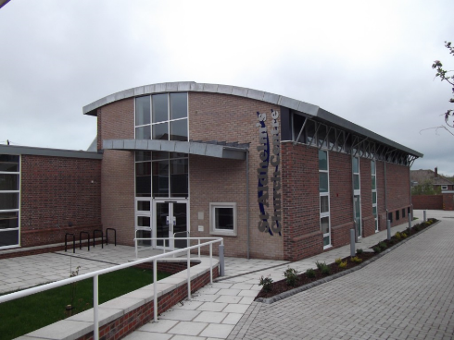
Joining Instructions
St Aldhelm’s Church Hall
Spa Road
Weymouth, Dorset
DT3 5EW

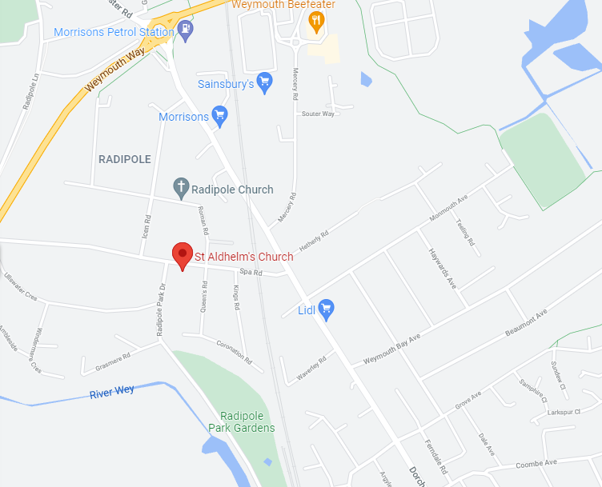
In light of the COVID concerns please ensure you check the Dorset Road safe website Dorset Road Safety | Dorset Road Safety for updates in relation to classroom cancellations

Directions.
From A354 Weymouth Relief road: Follow the road into Weymouth taking the 2nd exit on both roundabouts, Morrison will be on the left. At Manor Roundabout take the 1st exit onto Dorchester Road carrying straight on through 3 sets of traffic lights. Immediately after the 3rd set of lights turn right onto Spa Road. The church will be on the left. The car park is at the rear of the church.
From B3157 Coast Road: Head into Chickerell towards Weymouth, at the traffic light junction turn left continuing on B3157 towards Weymouth. At Wessex Roundabout take the 3rd exit continuing on the B3157, at Chafey’s Roundabout take the 2nd exit onto A354 towards College, at Manor Roundabout take the 3rd exit onto Dorchester Road towards the College. Carry straight on through 3 sets of traffic lights. Immediately after the 3rd set of lights turn right onto Spa Road. The church will be on the left. The car park is at the rear of the church.

Classroom location: The course is in Room 5 located on the 1st Floor. A lift is available if required.

Free car park on site. Disabled parking is available.

Refreshments: Free Tea/Coffee will be available during the break.

Smoking: Please note this is a NO SMOKING site

Please see our website for further details www.dorsetroadsafe.org.uk

PLAN YOUR JOURNEY

Please ensure you check your planned route for any roadworks that may delay your journey.

Details of planned roadworks for the Dorset area can be found on:

www.dorsetforyou.gov.uk

www.bournemouth.gov.uk

www.poole.gov.uk/transport-and-streets/roads-highways-and-pavements/road-works

Please be aware

As per our terms and conditions latecomers will NOT be admitted to the course which will result in the course offer being withdrawn.

THE ORIGINAL COURSE FEE IS NON-REFUNDABLE

