 

Link Validation – Road Layout Confirmation

Dorset SafeZone average speed enforcement links

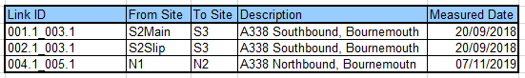

Confirmation from Customer on Road Changes On behalf of

BCP Council

I confirm that there have been no road layout changes that impact these links as originally measured.

Signed 

Date

6/10/23

Unrestricted