
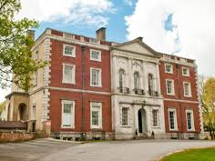
Joining Instructions
Merley House
Merley House Lane
Wimborne
BH21 3AA
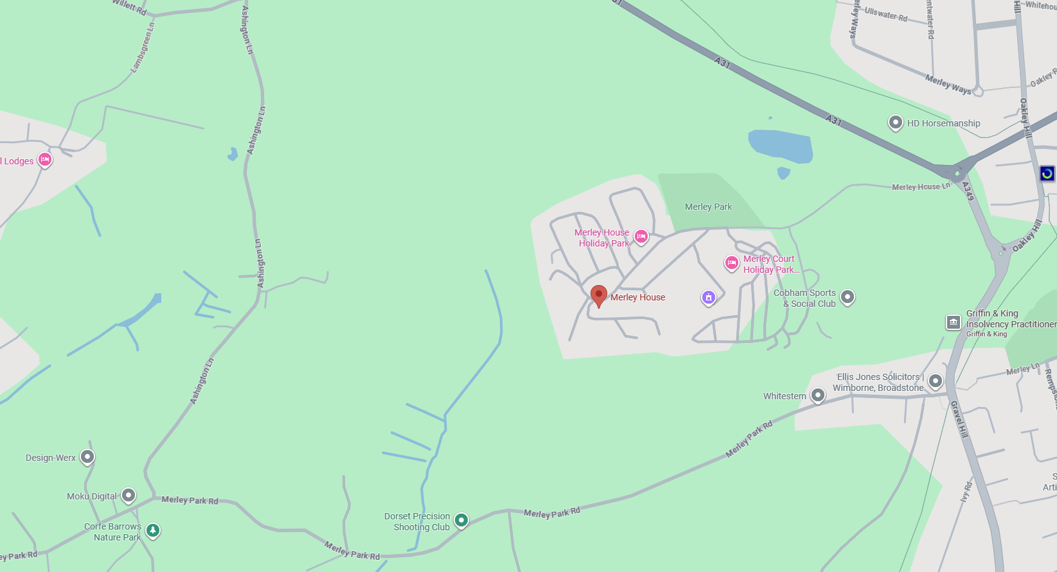
What 3 Words: rice.shadow.tests

Directions:
By Car - Located on Merley House Lane, directly off Merley roundabout (A31 Wimborne bypass and A349 Poole Junction).

Once you come off the Merley roundabout, follow the road up the hill and continue straight along over the speed bumps. The car park is on your left-hand side opposite the reception (which is separate to us) you will go through the red and white barrier and park on your left-hand side, then you will see the house in front of you. Please walk up the lane to the house and enter through the red doors.

You can get to Merley House by Bus. These are the lines and routes that have stops nearby -
Bus: 3

Classroom location:
The classroom is situated on the ground floor. Please proceed to the old library where you will be met by an instructor for registration.

Parking:
Free car park on site. Disabled parking spaces available.

Refreshments:
Free tea/coffee is available at the break during your course.

Smoking:
Please note that the building is a NO SMOKING site: you may smoke in any designated outside areas.

Please see our website for further details www.dorsetroadsafe.org.uk

PLAN YOUR JOURNEY

Please ensure you check your planned route for any roadworks that may delay your journey.

Details of planned roadworks for the Dorset area can be found on:

www.dorsetforyou.gov.uk

www.bournemouth.gov.uk

www.poole.gov.uk/transport-and-streets/roads-highways-and-pavements/road-works

Please be aware:

As per our terms and conditions latecomers will NOT be admitted to the course which will result in the course offer being withdrawn.

THE ORIGINAL COURSE FEE IS
NON-REFUNDABLE

