
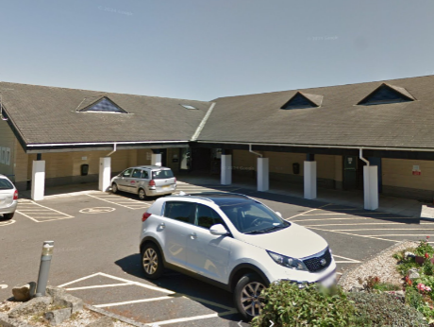
Joining Instructions
Canford Magna Complex
Magna Road, Canford Magna
Wimborne
BH21 3AP
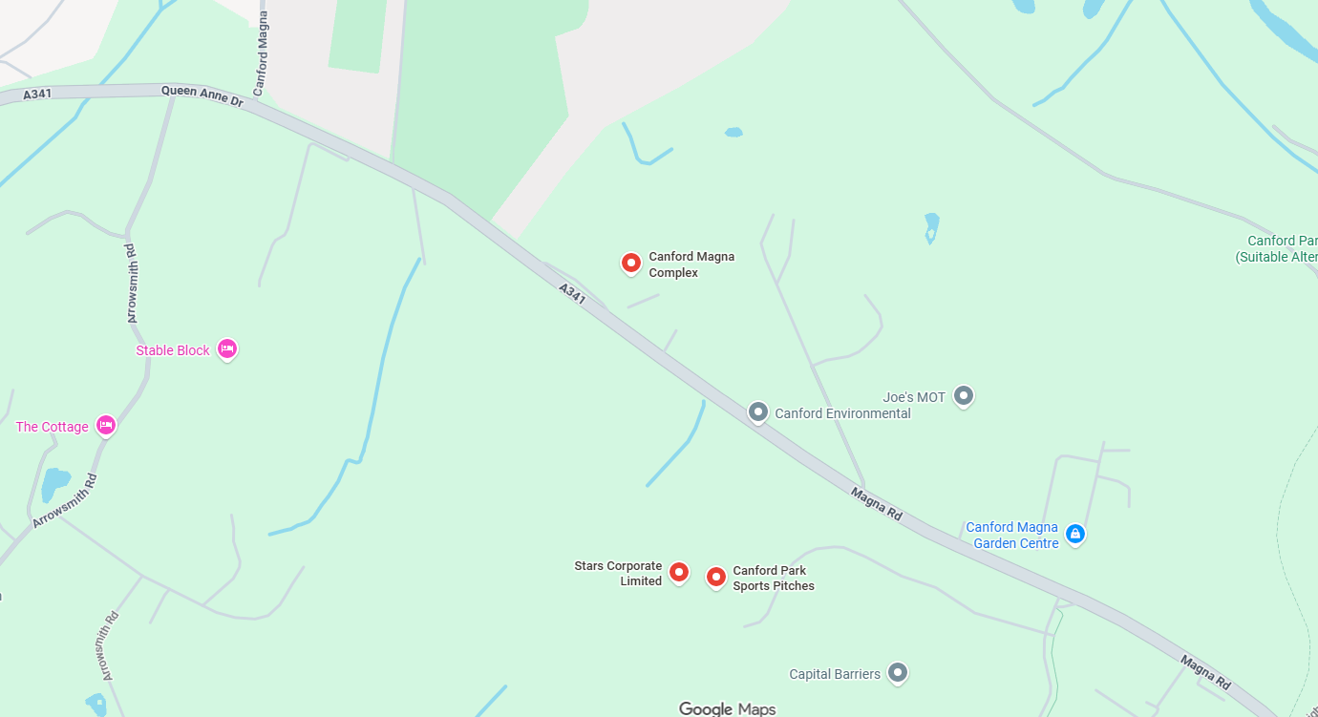
What 3 Words: arch.valuables.corrects

Directions:
The Canford Magna Complex is situated on the Magna Road (A341) between Canford Magna and Bearwood.

From Bearwood the Complex is approximately 2 miles along the A341(Magna Road) on the right. Passing through traffic lights with Canford Park Arena on the left and Superbuys on the right, the Complex is about ¼ mile further on.

From A349 turning left onto A341 (Queen Ann Drive which merges with Magna Road), the Complex is approximately 1 ½ miles along just past the turning for Canford Magna Village. The left turn for the Complex is directly after a large lay-by on the left.

Classroom location:
The classroom is situated on the ground floor. Please proceed to the bar area where you will be met by an instructor for registration.

Parking:
Free car park on site. Disabled parking bays available close to the building. please do not park in the bottom carpark

Refreshments:
Free tea/coffee is served from the far end of the bar at the break during your course. In addition, you may wish to buy refreshments/meal from the bar in the complex.

Smoking:
Please note that the building is a NO SMOKING site: you may smoke in any designated outside areas.

Please see our website for further details www.dorsetroadsafe.org.uk

PLAN YOUR JOURNEY

Please ensure you check your planned route for any roadworks that may delay your journey.

Details of planned roadworks for the Dorset area can be found on:

www.dorsetforyou.gov.uk

www.bournemouth.gov.uk

www.poole.gov.uk/transport-and-streets/roads-highways-and-pavements/road-works

Please be aware:

As per our terms and conditions latecomers will NOT be admitted to the course which will result in the course offer being withdrawn.

THE ORIGINAL COURSE FEE IS
NON-REFUNDABLE

